BIT4107-Mobile Application Development

Student Name: David Maina
Admission Number: BIT/2024/37478
School/faculty: School of computing and informatics
Programme: Bachelor of Science in Information Technology
Academic Year: Fourth year
Semester: MAY-AUGUST 2026
Lecturer Name: Michael Nyoro
Phone Number: 0795403214

Table of contents
BIT4107-Mobile Application Development 1
Week 1: Introduction to mobile development. 1
1.1 Tools/software used 2
1.2 Personal reflection 3
Week 2: Mobile Development Environment. 3
2.1 Tools/software used 5
2.2 Personal reflection 5
Week 3: User Interface Design 5
3.1 Tools/ Software used 8
3.2 Personal reflection 9

Week 1: Introduction to mobile development.

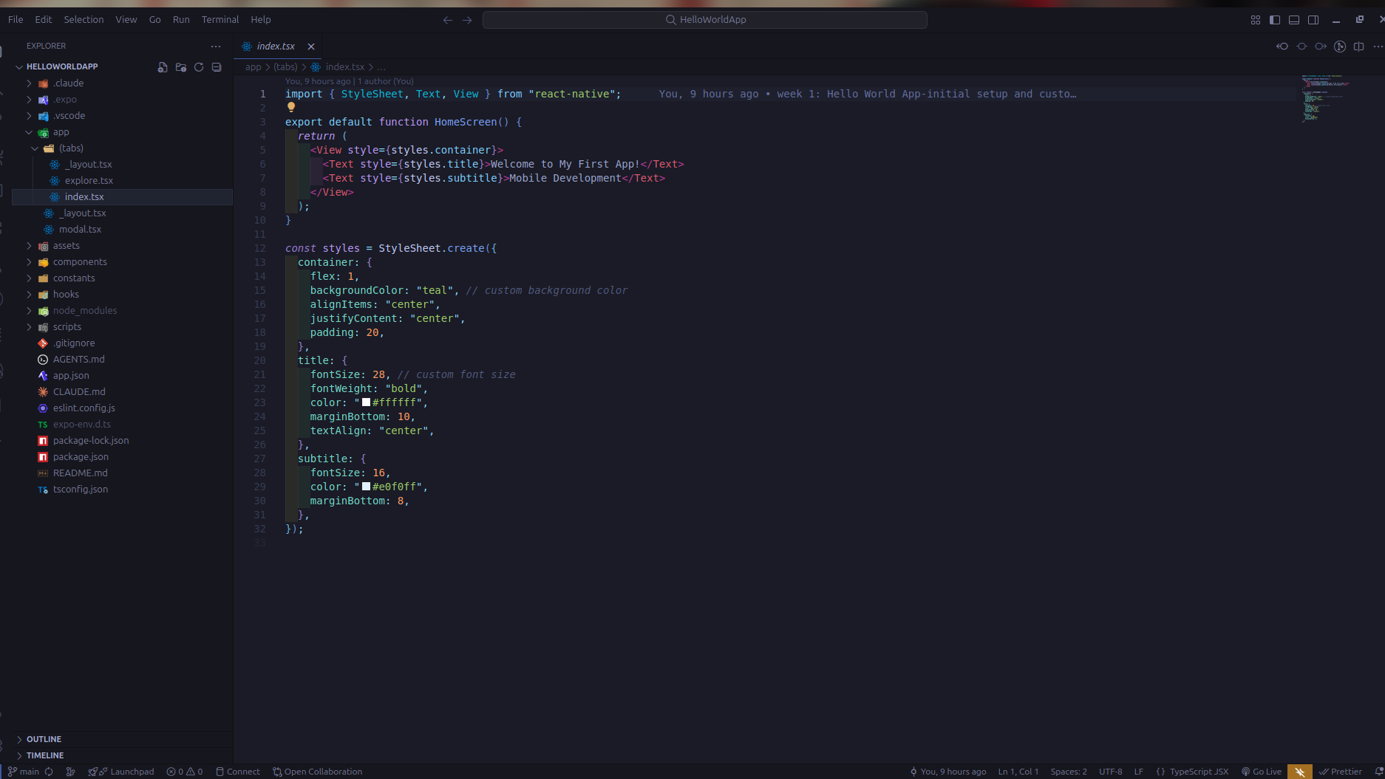Fig.1.0: vs code installed.

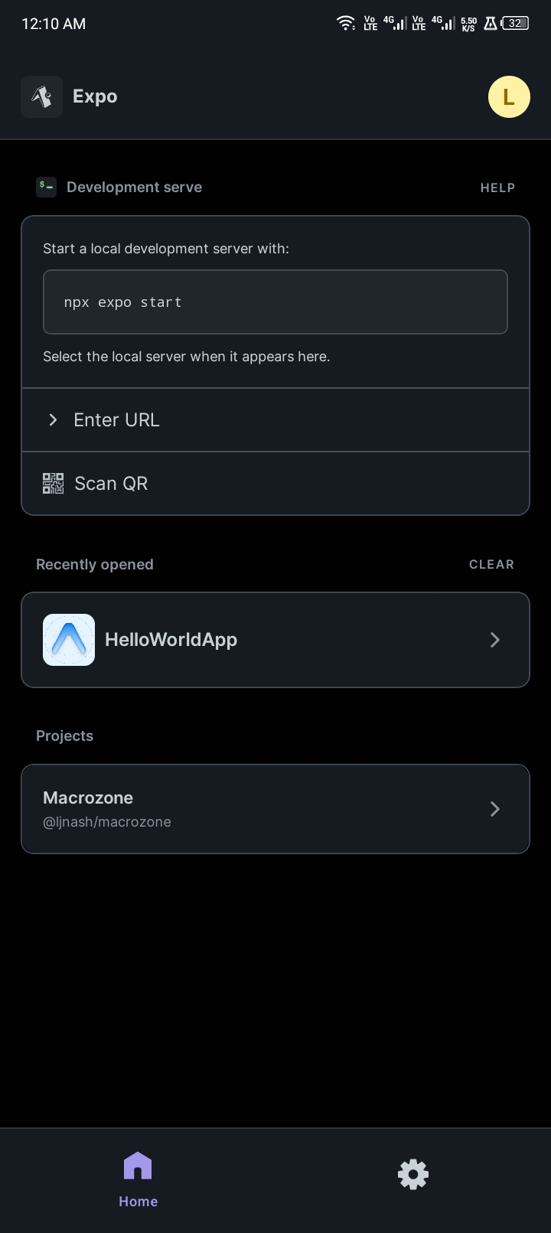
Fig.1.1: Installation of expo go on mobile device

1.1 Tools/software used
1. vs code
2. Expo Go
3. Android Smartphone
4. Internet Browser

1.2 Personal reflection
During setup, Expo Go could not run my project because it did not support Expo SDK 55. After investigating the issue, I downgraded to SDK 54, which was supported and more stable. This experience improved my troubleshooting skills and understanding of development environment compatibility.

Week 2: Mobile Development Environment.

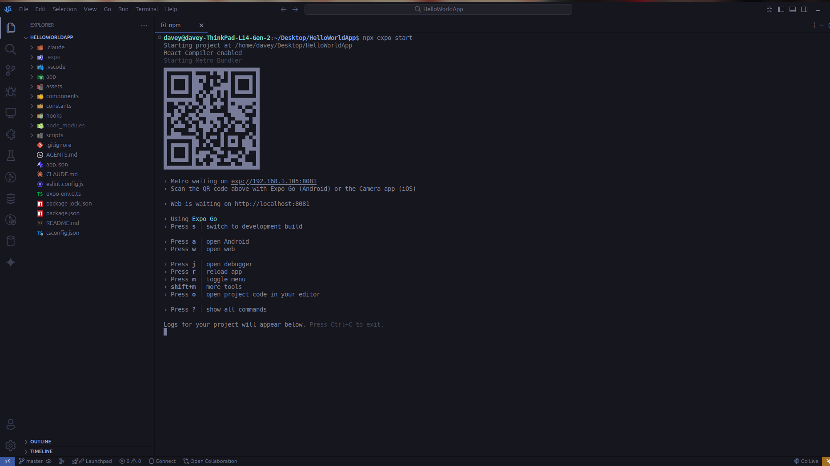Fig.2.0: Running with expo Go

Fig.2.1: code Output displayed on mobile device

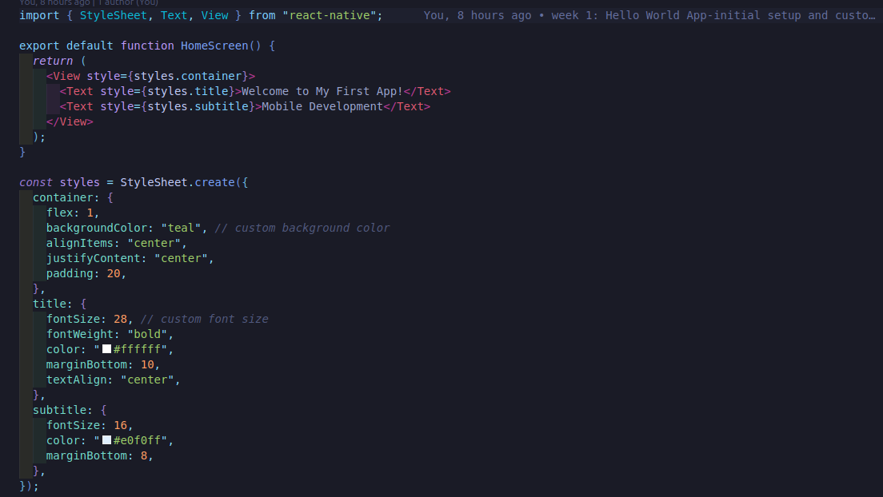 Fig.2.2: Code snippet.

2.1 Tools/software used
1.vs code
2.node.js
3.npm
4.Expo
5.Expo Go
6.Android Smartphone

2.2 Personal reflection
This week I successfully connected my mobile device to the Expo development server and ran my first React Native application. Seeing code changes reflected instantly on my phone helped me understand the mobile development workflow and improved my confidence in using Expo and React Native.

Week 3: User Interface Design

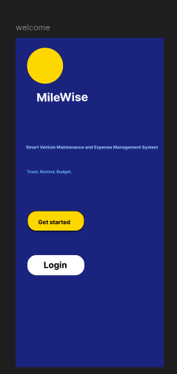
Fig 3.0: MileWise welcome Screen Wireframe - Figma
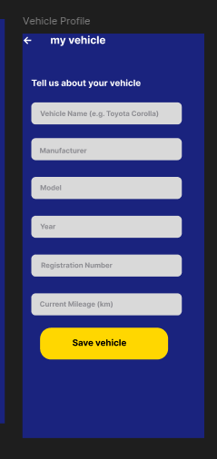
Fig 3.1: MileWise vehicle Profile Screen Wireframe - Figma
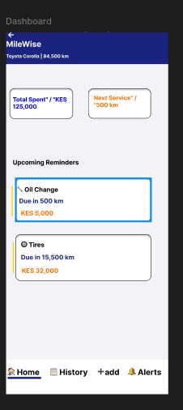
Fig 3.2: MileWise Dashboard Screen Wireframe - Figma

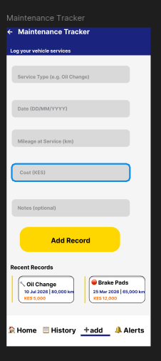
Fig 3.3: MileWise Maintenance Tracker Screen Wireframe – Figma
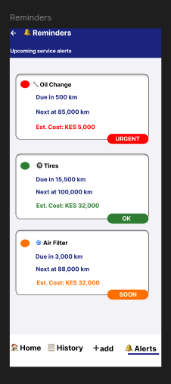
Fig 3.4: MileWise Reminders Screen Wireframe – Figma

3.1 Tools/ Software used
1.Figma

3.2 Personal reflection
This week I learned the importance of planning the user interface before development. Creating wireframes in Figma helped me visualize the application structure, improve navigation flow, and identify design improvements before writing code.

